The musical style and creative aesthetic of Franz Liszt

Franz Liszt was a 19th-century Hungarian composer, pianist, and teacher. He was one of the prominent composers in Romantic period. In early years, he took piano lesson with Carl Czerny and composition lesson with Antonio Salieri. Furthermore, Liszt was inspired by Niccolò Paganini’s virtuosity and he developed the similar technique on his piano works, especially on his Studies. Liszt as a composer, he left behind an extensive and diverse body of work in which he influenced his forward-looking contemporaries and anticipated many 20th-century ideas and trends. Some of his most notable musical contributions were the invention of the symphonic poem, developing the concept of thematic transformation as part of his experiments in musical form and making radical departures in harmony. Besides that, the idea of piano recital was also invented by Liszt. This essay will talk about Liszt’s three significant aspects of the musical style and creative aesthetic, which are virtuosity, nationalism, and symphonic poem.

Some people argue that Liszt was the first who evoked the idea of dark and mad virtuosity of the age, in fact he was not. Niccolò Paganini was the most important person who inspired Liszt, as a violinist. In April 1832, Liszt attended Paganini’s concert in Paris, he was amazed by Paganini’s playing and determined to transfer Paganini's style of virtuosity to the keyboard. Liszt made an unprecedented breakthrough in piano technique during the 1830s and 40s, this breakthrough presented a range of new technical and expressive possibilities. Moreover, the evolution of the instrument is also a significant factor to Liszt’s virtuosity. Because of instrument’s greater strength, bigger sound and wider dynamic range, allowed to develop more possibilities.
For building up the virtuosity, Liszt spent most of the time on endurance exercises in his practice, such as scales, arpeggios, trills, and repeated notes. However, Liszt did something more than that, he also introduced some unusual twists, hand-changings, and fingerings in his “Technical Exercises”. The “Technical Exercises” were written within 1868 to 1873, and the purpose is establishing the basic techniques for playing his virtuoso pieces. For example, the exercise no.52 and no.53 shows the scale in different keys or chromatically with alternating hands.
Ex. 1 Liszt, Technical Exercises, Book 3, Exercise no. 52
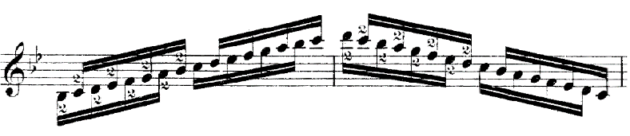
Ex. 2 Liszt, Technical Exercises, Book 3, Exercise no. 53
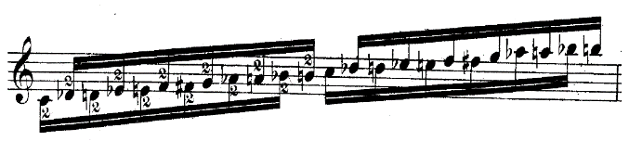

Chromatic octaves, as known as “Liszt octaves”, was one of the notable features of Liszt’s virtuosity. This technique could create some spectacular storm effects, and the same concept could be found in exercise no.53. The following example comes from the Paganini Study no.2.
Ex. 3 Liszt, Grandes étude de Paganini no. 2, 21.
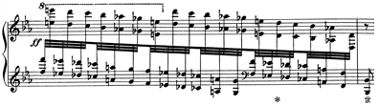

Leaps are another feature of Liszt’s virtuosity, Liszt himself clearly enjoyed to take risks. This technique is insecure and difficult to play in big leaps, the player is required to feel the piano as his own body. A passage from the Paganini Study no.3 shows the example of this technique.
Ex. 4 Liszt, Grandes étude de Paganini no. 3, 5-7.
Note-repetition was another technique of keyboard playing whereas Liszt made up his own version. This technique could produce dreamy effect, and it demands to play rapidly in Liszt’s version. The Tarantella movement in Venezia e Napoli has a passage to show as an example.
In addition, trills and tremolos are demanding in his virtuoso pieces. In the music of other Romantic period composers, this technique is not often used. The difficulties in this technique are different fingering trill and left-hand trill. Here is an example in the Paganini Study no.6.
Ex. 5 Liszt, Grandes étude de Paganini no. 6, Var.10, 1-6.
The works most representative of Liszt’s virtuosity are the 6 Paganini Studies and the 12 Transcendental Studies. The Paganini Studies are composed under the influence of Paganini. Most of the studies are based on Paganini’s 24 Caprices for solo violin, except Study no.3 which is from the Rondo of Paganini’s Violin Concerto in B minor. On the other hand, the Transcendental Studies were written with a dedication to his teacher Czerny, which are much harder than the Paganini Studies. These eighteen pieces were the first technical breakthrough at the piano and represented Liszt’s Virtuosity.

About his nationalism, some people have an opinion on Liszt should not consider himself as a Hungarian, the position of himself is complicated. Because his ancestry from his father’s side was German, and his mother’s side was Austrian. Liszt never learnt Hungarian, his mother tongue was German and he spoke French in most of his adult life. Thus, his nationality was Hungarian but culturally he was not. However, Liszt did have strong interest in traditional Hungarian and Gypsy folksongs, and undoubtedly his nationalism in his music is strong. Liszt contained many Hungarian folksongs that he had heard from his hometown in Hungary, which he believed to be folk music, although most of the tunes were written by members of the Hungarian bands, or by composers. The Hungarian works are divided to two periods, which are 1870 – 1873 and 1881 – 1885. In 1881, Liszt returned to his hometown, and attempts to experiment and compose more Hungarian music.

The most significant material in the Hungarian works is Gypsy improvisation. This material was inspired by the Gypsy bands, with their unique improvisatory effects. Liszt preserved the two main elements of typical Gypsy improvisation, which are the lassan (slow) and the friska (fast). Meanwhile, some special effects from the sonic surface of the Gypsy band are applied in his Hungarian Rhapsodies. The following example comes from the beginning of the Hungarian Rhapsody no.11.
Ex. 6 Liszt, Hungarian Rhapsody No.11, 1-2.
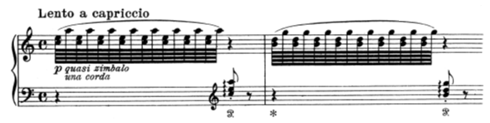
Gypsy Scale is another material in his nationalism. This scale can be found by sharpening the fourth degree of harmonic scale, which creates tragic and depressing effect. A passage from the Hungarian Rhapsody no. 13 is probably the best example.
Ex. 7 Liszt, Hungarian Rhapsody no.13, 4-5.
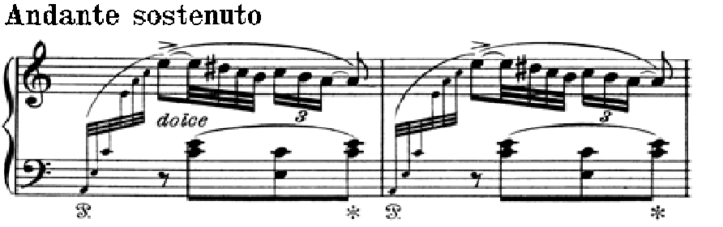

Some of the Hungarian folksongs are also used in the Hungarian Rhapsodies. In 1840s he composed a set of pieces called Hungarian National Melodies based on the materials he heard from native land, these melodies were used in the Hungarian Rhapsodies. For example, Magasan repül a daru szépen szól, this folksong is about a funeral lament for a dead legend, with drums in the background. Which used in Hungarian Rhapsody no. 14, as we can see left hand represents the drums and the melody in right hand.
Ex. 8 Liszt, Hungarian Rhapsody No.14, 3-4.
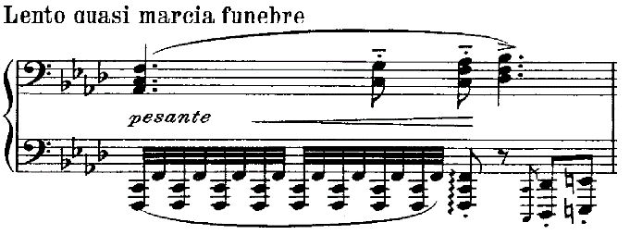
In addition, his last four rhapsodies are based on Csárdás, which is a fast Hungarian dance in 2/4 time.

The most representative works of his nationalism is Hungarian Rhapsodies. No.1 – 15 were composed between 1846 and 1853, No.16 – 19 were 1882 to 1885. Hungarian Rhapsodies are composed under the influences of Gypsy bands and composers. Most of his rhapsodies were dedicated to someone, except No.15, and No.17 – No.19. Moreover, some of the rhapsodies were arranged for orchestra by Franz Doppler, with revisions by Liszt himself. Also, Liszt himself arranged some of the rhapsodies for piano duet.

In 1853, Liszt presented the term “Symphonic Poem” which is a piece of orchestral music with a single continuous movement. This genre illustrates the content of non-musical materials, such as a poem, short story, novel, painting, or landscape. These materials are the spirit of symphonic poem, some of the works even come with an autographical explanation. In fact, the origins of the genre were no difference between the concert overture, for example Beethoven’s overtures show the concentration and expressive power characteristic of his one-movement works. The structure of the symphonic poem focus on reducing the recapitulation while codas assume developmental proportions and thematic transformation which means create new and unexpected themes.

There are two main features which Liszt used in his symphonic poems. First, the cyclic form, which is a theme, or melody appears in more than one movement. This form was established by Beethoven in certain movements are not only linked but reflect one another’s content. Liszt took Beethoven's form one step further, combining separate movements into a single-movement cyclic structure.

Thematic transformation is another feature, it is a musical technique which develops and repeats the theme by changing the key, pace, or colour. This technique was mainly developed by Liszt and Berlioz. In fact, they were not the first composers who used the technique in their works. For instance, Beethoven’s Symphony no.9 had already applied this technique on the sublime “Ode to Joy” theme, which transformed into an odd Turkish march with cymbals and drums. Furthermore, Schubert also used the technique to bind together the four movements of his Wanderer Fantasy, a work which influenced Liszt greatly. However, Liszt mastered the technique and applied in his most of the works, especially symphonic poems.

Between 1856 and 1861, the twelve symphonic poems were composed and published during Liszt’s Weimar years. These symphonic poems are dedicated to Princess Carolyne and titled. Four of the symphonic poems were written under the idea of heroism and legend, which are Tasso, Orpheus, Prometheus, and Mazeppa. Moreover, three of symphonic poems, Ce qu'on entend sur la montagne, Les préludes, Die Ideale are linked to poems that do not deal with a particular character. Furthermore, three of the symphonic poems have no preface at all, which are Festklänge, Hungaria, Hamlet. The preface of Héroïde funèbre focuses on the immobility of grief in human existence. Hunnenschlacht is the only one inspired by a painting, which painted by Wilhelm von Kaulbach. Liszt stopped composing symphonic poem after Hamlet (1858), the last symphonic poem that he composed is Von der Wiege bis zum Grabe which completed in 1883.

In conclusion, Liszt as a composer and pianist did lots of contribution to music. Many factors and composers influenced Liszt’s music, such as Paganini, Beethoven, Hungarian origin, German training in his early year, and program music. As we can see, Paganini’s impact was very powerful to Liszt. Liszt had imitated Paganini’s virtuosity and advanced keyboard playing techniques. But, Liszt was not the only one who distinguished virtuosic piano playing, there was a competition between the other pianists, such as Chopin and Thalberg. Also, Liszt composed Hungarian music as well, by using national tunes. Not many people focus on the research of his Hungarian music, because Liszt used more gypsy music than true Hungarian folk tunes and they do not think Liszt was fully understood Hungarian folk music. Some scholars think Liszt’s Hungarian music does not represent true folk music in the way that Bartók did. Furthermore, Liszt developed the symphonic poem and it was widely influential. This genre inspired few important composers, for example Smetana, Franck, Saint-Saens, and Tchaikovsky. Finally, these three significant aspects of musical style and creative aesthetic had inspired 20th century composers, such as Saint-Saen, Ravel and Bartók.

Walker, Alan: ‘Liszt, Franz’, Grove Music Online (Oxford University Press, 2001), accessed 6 April 2017, http://www.oxfordmusiconline.com/subscriber/article/grove/music/48265#S48265.
Ibid.
Burkholder, Peter J, Grout, Donald Jay, and Palisca, Claude V: A History of Western Music, 9th edition. (New York and London: W.W. Norton and Co., 2014), 618.
Walker, Alan: Franz Liszt: The Virtuoso Years (London: Faber and Faber, 1989), 173.
Ibid, 296.
Walker, Alan: ‘Liszt, Franz: Liszt and the piano’
Ibid.
Walker, Alan: Reflections on Liszt (New York: Cornell University Press, 2005), 206.
Ibid, 203.
Ibid, 204.
Ibid, 206.
Walker, Alan: Reflections on Liszt, 209.
Ibid, 210.
Ibid, 211.
Walker, Alan: Franz Liszt: The Virtuoso Years (London: Faber and Faber, 1989), 305.
Ibid, 305.
Burkholder, Peter J, Grout, Donald Jay, and Palisca, Claude V: A History of Western Music, 618.
Burkholder, Peter J, Grout, Donald Jay, and Palisca, Claude V: A History of Western Music, 618.
Walker, Alan: Franz Liszt: The Virtuoso Years, 341.
Hamilton, Kenneth: The Cambridge Companion to Liszt (New York: Cambridge University Press, 2005), 107.
Ibid, 108.
Walker, Alan: Franz Liszt: The Virtuoso Years, 335.
Ibid, 336.
Walker, Alan: Franz Liszt: The Virtuoso Years, 336.
Ibid, 336.
Ibid, 335.
Ibid, 336.
Hamilton, Kenneth: The Cambridge Companion to Lisz, 110.
Gardonyi, Zoltan: ‘Doppler, Franz’, Grove Music Online (Oxford University Press, 2001), accessed 6 April 2017, http://www.oxfordmusiconline.com/subscriber/article/grove/music/08024pg1.
Walker, Alan: ‘Liszt, Franz: Symphonic poems’, Grove Music Online (Oxford University Press, 2001), accessed 6 April 2017, http://www.oxfordmusiconline.com/subscriber/article/grove/music/48265pg15#S48265.
Walker, Alan: Franz Liszt: The Weimar Years (London: Faber and Faber, 1989), 305.
Macdonald, Hugh: ‘Symphonic poem’, Grove Music Online (Oxford University Press, 2001), accessed 6 April 2017, http://www.oxfordmusiconline.com/subscriber/article/grove/music/27250?q=symphonic+poem&search=quick&pos=1&_start=1#firsthit.
Walker, Alan: ‘Liszt, Franz: Symphonic poems’
Walker, Alan: Franz Liszt: The Weimar Years, 357.
Ibid, 357.
Ibid, 310.
Ibid, 310.
Ibid, 310.
Hamilton, Kenneth: The Cambridge Companion to Liszt, 206.
Walker, Alan: ‘Liszt, Franz: Symphonic poems’
Hamilton, Kenneth: The Cambridge Companion to Liszt, 207.
Ibid, 213.
Ibid, 214.
Hamilton, Kenneth: The Cambridge Companion to Liszt, 214.
Ibid, 215.
Hamilton, Kenneth: The Cambridge Companion to Liszt, 215.

